EXPERIMENT 4

AIM:
To detect and study radiation produced by ¹³⁷Cs and ⁶⁰Co with a scintillator counter using a multi-channel analyzer.
- Given that the energy of gamma rays in decay of Co-60 is 1.17 MeV and 1.33 MeV, find the channel number corresponding to the photopeak of these 2 energies and find the relation between channel number and energy.
- Find the energy of gamma ray in decay of Cs-137.
- Find the photopeak efficiency of Co-60.
- Study the variation of resolution for 2 Co-60 peaks with variation of PMT voltage.

SOURCES:
Gamma-ray sources used in this experiment are Cs-137 (1 peak) and Co-60 (2 peaks).
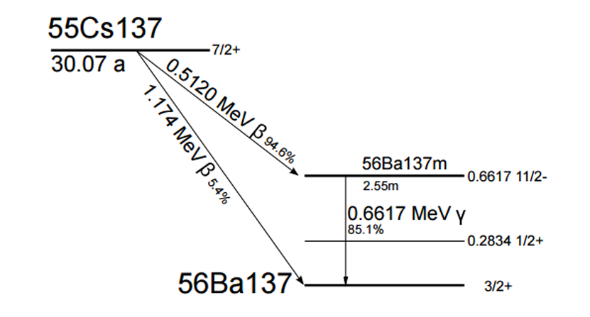
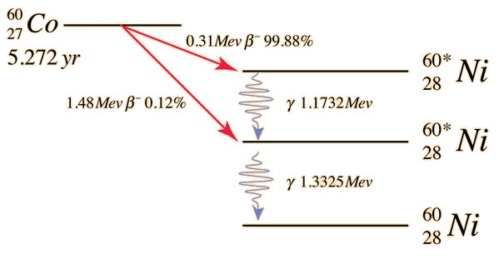
Figure 1: Decay Scheme of Cs-137
Figure 2: Decay Scheme of Co-60
THEORY:
1) β⁻ decay:
- β⁻ decay occurs as follows:

n p + e⁻ + ${\overline{ν}}_{e}$

n – neutron
p – proton
e⁻ - electron (called the β particle)
${\overline{ν}}_{e}$ – antineutrino

- The mass number (p + n) remains the same whereas the atomic number (p) increases.
- e⁻ and ${\overline{ν}}_{e}$ are released to conserve charge, energy and momentum. They carry away the energy and momentum.

2) Decay of ¹³⁷Cs:
- ¹³⁷Cs (Z = 55) decays into ^{137m}Ba (Z = 56) (m – metastable, meaning it is not the most stable nuclear state) through β⁻ decay.
- The β⁻ decay energy spectrum is a continuous spectrum since the energy emitted in the decay is shared between the antineutrino and the e⁻.
- The β particle (e⁻) can have a maximum energy of 512 keV, when the antineutrino has almost 0 energy.
- ^{137m}Ba releases a gamma photon, having a characteristic energy of 662 keV to reach its ground state. This is what is detected by the scintillator counter as the peak of the ¹³⁷Cs distribution.

¹³⁵Cs ^{137m}Ba + e⁻ + ${\overline{ν}}_{e}$

^{137m}Ba ¹³⁷Ba + γ (662 KeV)

3) Decay of ⁶⁰Co:
- Co-60 (Z = 27) undergoes β⁻ decay to Ni-60 (Z = 28).
- The emitted β⁻ particle (electron) and antineutrino carry away most of the decay energy.
- The daughter nucleus Ni-60 is left in an excited state, which emits two γ rays (1.17 MeV and 1.33 MeV) as it returns to the ground state.
⁶⁰Co ⁶⁰Ni* + e⁻ + ${\overline{ν}}_{e}$
⁶⁰Ni* ⁶⁰Ni + γ₁ (1.173 MeV) + γ₂ (1.33 MeV)

5) Compton Scattering:
- In this case, the γ-ray is not absorbed but scattered through an angle $θ$ by the electron, which recoils and carries away some of the energy of the gamma ray.
- The scattered electron energy is detected by the PMT. The gamma-ray escapes from the scintillator as the probability that a gamma-ray Compton scatters in the scintillator is quite small.
- The equation for energy of scattered electron is:

$$E'= \frac{\frac{E^{2}}{mc^{2}}(1-\cos{θ)}}{1+\frac{E}{mc^{2}}(1-\cos{θ)}}$$

E = energy of gamma-ray
E’ = energy of scattered electron
$θ$ = angle of scattering
m = mass of electron
c = speed of light

- At $θ$ = 0º: E’ = 0 (minimum energy of electron).
At $θ$ = 180º: E’ = $\frac{2E^{2}}{{mc}^{2}+2E}$ (maximum energy of electron). This maximum energy is called the Compton edge. For E = 662 keV, it is around 478 keV.

The energy of the electron lies in this range.

4) Chain of Detection:
Scintillator → PMT → Preamplifier → Amplifier → MCA
- Scintillator: Converts γ-ray energy into light.
- PMT (Photo Multiplier Tube): Converts light into an electrical pulse; amplitude ∝ light output ∝ γ-ray energy deposited.
- Preamplifier & Amplifier: Shape and amplify the signal to a standardized form.
- MCA: Digitizes and analyzes the pulse heights.

3) Detection by scintillator counter:
- The counter has scintillator crystals (like NaI(Tl)). When the γ-ray emitted enters the crystal, it can lose its energy by the following processes:

- Photoelectric Effect: γ photon absorbed, e⁻ ejected.
- Compton Scattering: γ photon scatters, e⁻ gets energy.
- Pair Production: If energy > 1.022 MeV.
In all the cases, the γ-ray energy is transferred to fast-moving e⁻s.
- The energetic electrons collide with other atoms of the crystal, exciting them. In pure NaI, these would have mostly returned to the ground state without producing visible light.
- This is why Thallium (Tl) is added as an activator. Excited e⁻s transfer their energy to Tl⁺ ions, which then return to ground state, emitting visible light photons ($λ$ $\sim$ 410 nm)
- This “scintillation” is efficient and gives a burst of light proportional to the γ-ray’s energy.

4) Photomultiplier Tube (PMT):
- The PMT has a photocathode coating. When it is hit by scintillation light, it knocks out photoelectrons by the photoelectric effect. The following is valid:

No. of emitted e⁻ $∝$ No. of photons $∝$ Energy of the γ-ray

- These electrons are directed towards a series of electrodes (dynodes), each at a higher positive voltage than the previous one.
- When an e⁻ strikes the 1st dynode, it ejects several secondary e⁻s. Each secondary e⁻ is accelerated to the next dynode, producing more electrons at each stage. After 10-12 dynodes, the initial few electrons are multiplied into millions.
- This large cloud of electrons reaches the anode, producing a measurable current pulse. The pulse height is proportional to the original number of scintillation photons, which is proportional to the γ-ray’s energy.
- If there are 10 dynodes, each at 50 V higher than the previous one, then total voltage gap:

V_{Total} = (50 x 100) V = 500 V
This is called the PMT Voltage or HV (High Voltage).
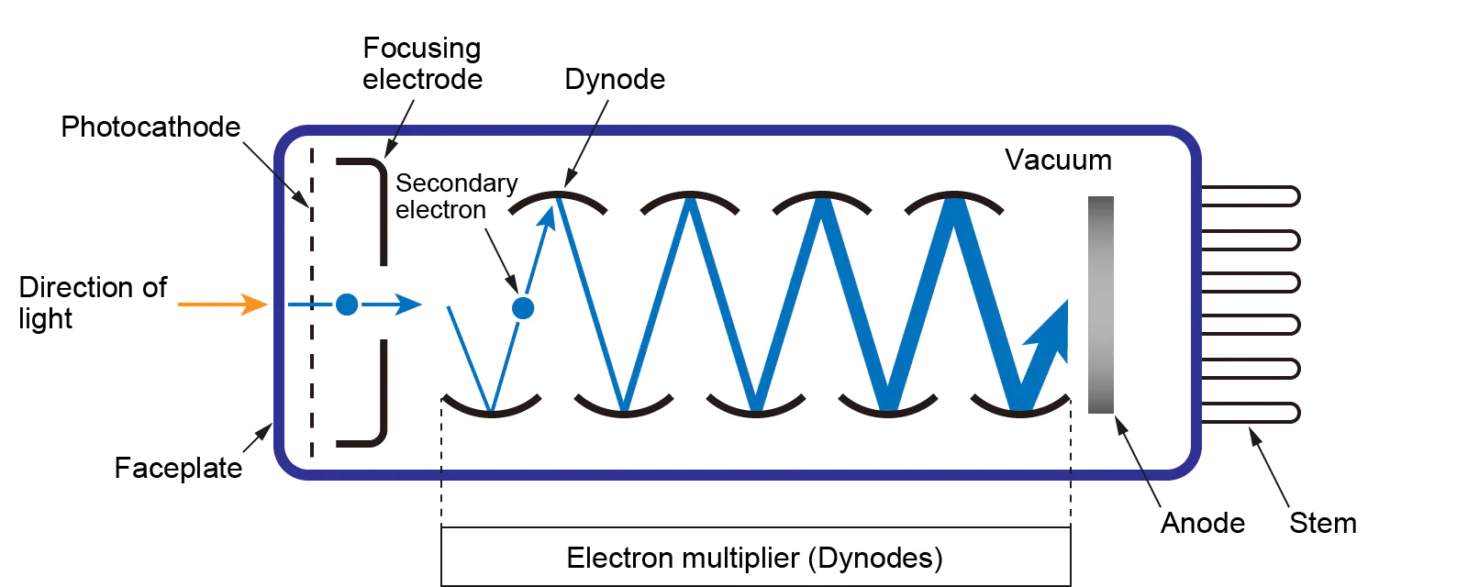
Figure 3: Structure of PMT
Figure 3: Structure of PMT

5) Multi-Channel Analyser (MCA):
- The amplifier outputs voltage pulses, each with an amplitude proportional to the γ-ray energy deposited. These analog pulses are sent to the MCA.
- The MCA contains an Analog-to-Digital Converter. Each pulse amplitude (a continuous voltage value) is converted into a digital number (e.g., between 0 and 1023 for a 10-bit ADC → 1024 channels).
- Small pulse Low energy Low channel number
- Large pulse High energy High channel number
- Once digitized, the MCA increments the count in the memory location corresponding to that channel number. Each channel acts like a bin in a histogram.
- After a sufficient number of events, the MCA plots Counts (y-axis) v/s Channel number (x-axis). Each photopeak appears as a distinct peak corresponding to a specific γ-ray energy.
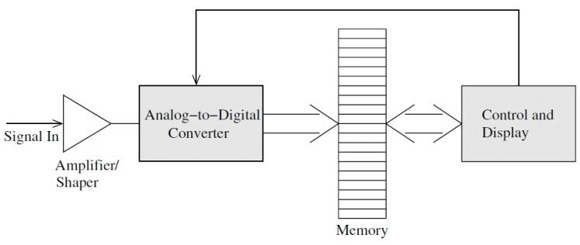
Figure 4: Working of MCA
6) Calibration of MCA:
Since we know the energies of some γ rays (e.g., 662 keV for Cs-137 and 1173, 1333 keV for Co-60), we can assign those to their measured channel numbers, and establish a linear calibration. We will be using the photopeak energies of Co-60 for calibration.
Photopeak 1: E_{A} = 1.333 MeV ; Channel Number = A
Photopeak 2: E_{B} = 1.173 MeV ; Channel Number = B
$$α=\frac{E_{B}-E_{A}}{B-A}$$
Any channel number can be converted into energy by the following relation:
Energy = α × Channel Number

OBSERVATIONS:
1) Spectrum for Cs-137:
PMT Voltage: 690 V
LLD (Low-Level Discriminator): 1
Time for reading: 600 seconds (10 mins)

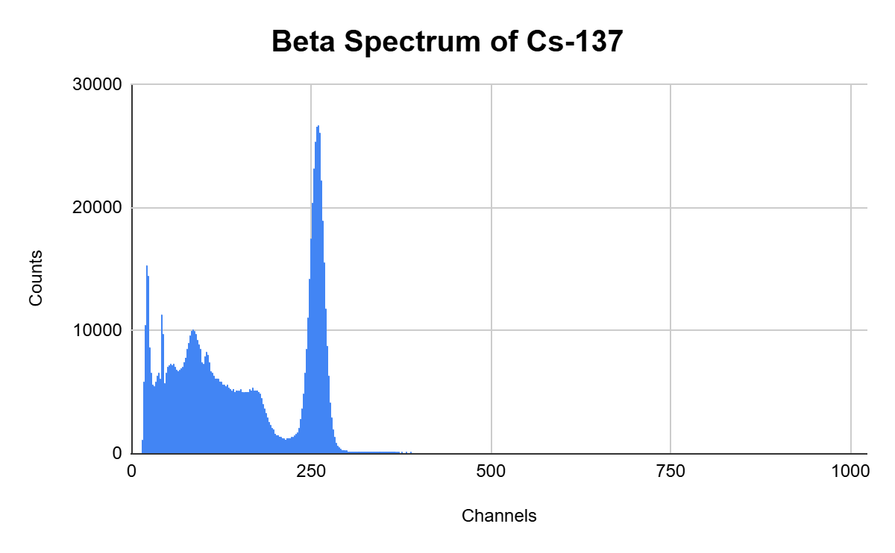

Figure 5: Energy Spectrum of Cs-137
The spectrum data for Cs-137 can be found here: https://docs.google.com/spreadsheets/d/1LADN9rjJka0mNNShIHzkL635i7caAQvasbtdT0BCtxY/edit?usp=drive_link

2) Spectrum for Co-60:
(a) At PMT Voltage = 690 V:
LLD (Low-Level Discriminator): 1
Time for reading: 600 seconds (10 mins)
The spectrum data for Co-60 can be found here: https://docs.google.com/spreadsheets/d/1V1aIVZavdSD5nf71TxGN_XT2T_l76u8bb5fNlmrcVe8/edit?usp=sharing
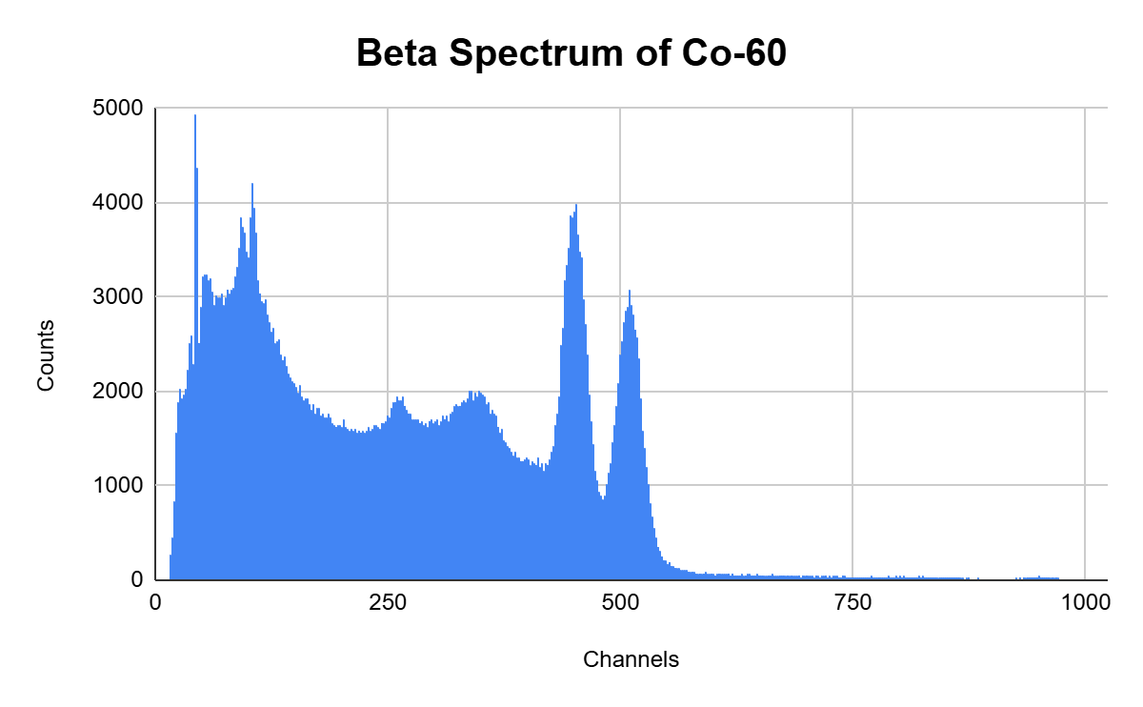
Figure 6: Energy Spectrum of Co-60 at 690 V
(b) With varying PMT Voltage:
LLD (Low-Level Discriminator): 1
Time for each reading: 300 seconds (5 mins)
The spectrum data for Co-60 can be found here: https://docs.google.com/spreadsheets/d/1wor23WuJ3QrbIekyTUUl6cHNKdCNBjHsi_Hd6J_P22U/edit?usp=sharing
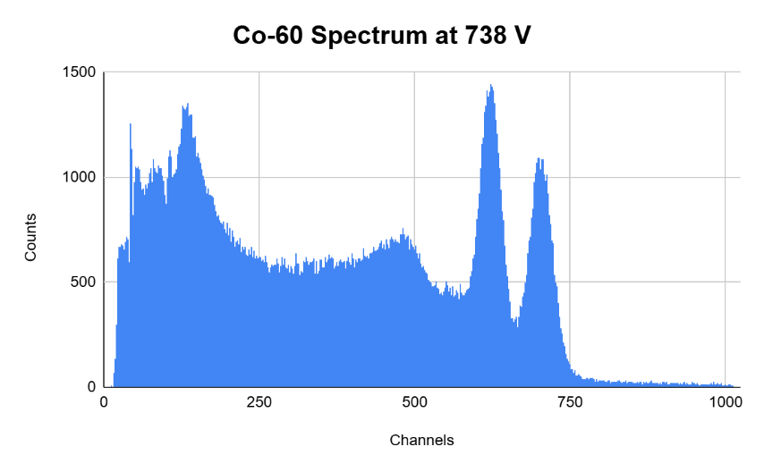
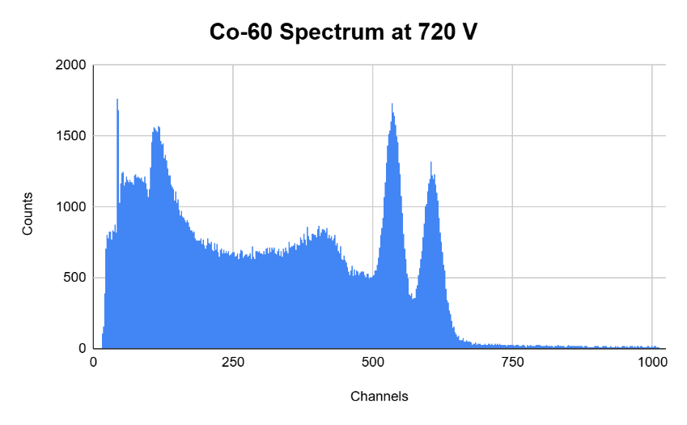
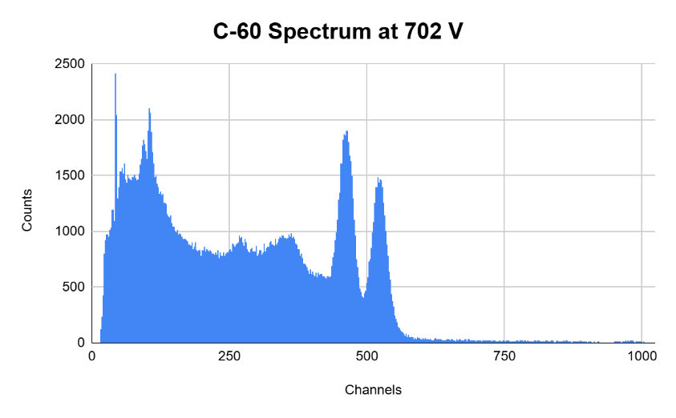
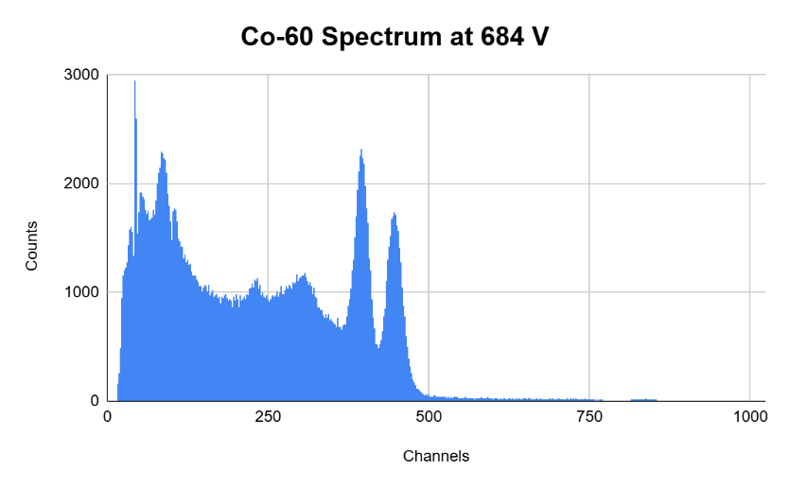
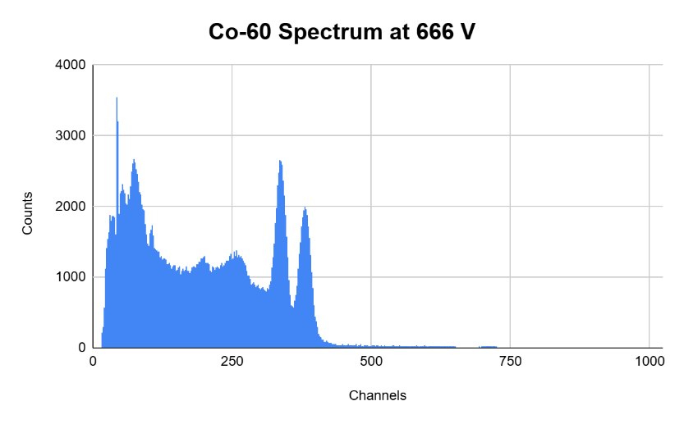
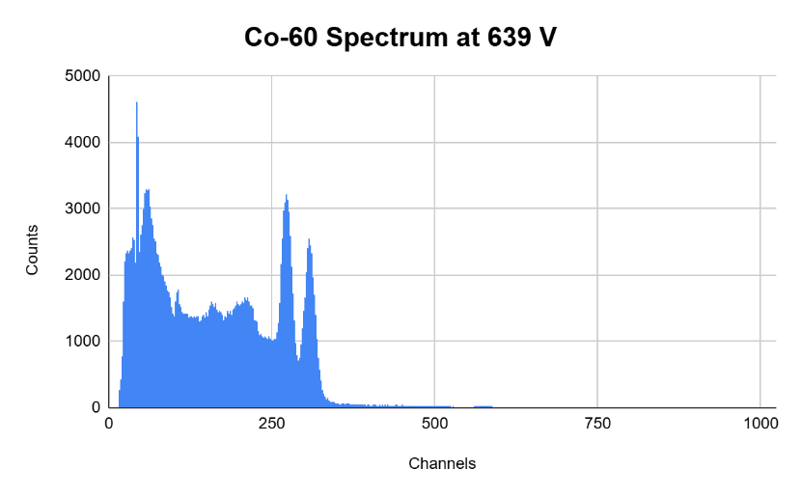
Figure 12: Co-60 Spectrum at 738 V
Figure 11: Co-60 Spectrum at 720 V
Figure 10: Co-60 Spectrum at 702 V
Figure 9: Co-60 Spectrum at 684 V
Figure 8: Co-60 Spectrum at 666 V

Figure 7: Co-60 Spectrum at 639 V

Below is Gaussian Fit of the Photopeak of Cs-137:
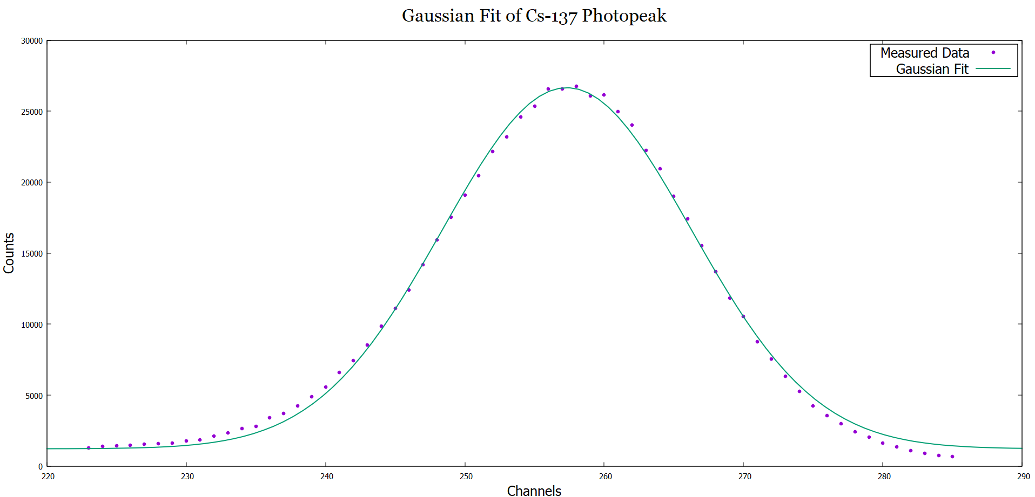
Figure 13: Gaussian Fit of Cs-137 Photopeak

ANALYSIS:
1) Calibration of MCA:
We fit the spectral data of Co-60 at 690 V with a 2-Gaussian function of the form:
$$f\left(x\right)=A_{1}ⅇ^{-{\left(x-μ_{1}\right)}^{2}∕2σ_{1}^{2}}+ A_{2}ⅇ^{-{\left(x-μ_{2}\right)}^{2}∕2σ_{2}^{2}}+(p_{0}+ p_{1}x+ p_{2}x^{2})$$

After fitting, the values obtained are:
Photopeak 1: A₁ = A = 450
Photopeak 2: A₂ = B = 509
$α=\frac{E_{B}-E_{A}}{B-A}=0.00271$ MeV
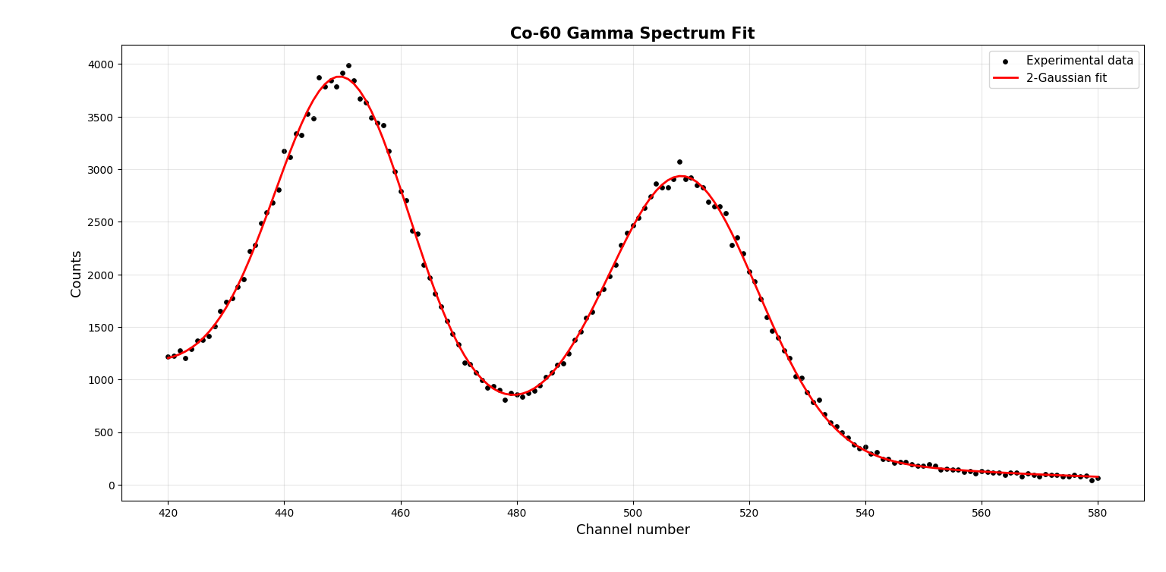
Figure 14: 2-Gaussian Fit of Co-60 Photopeaks at 690 V

2) Photopeak Energy of Cs-137:
From fitting the photopeak spectrum of Cs-137 with a Gaussian, the channel number at which the peak occurs is 257. From calculations:
E_{Cs} = α × 257 = 0.696 MeV

3) Photopeak Efficiency of Co-60 for different PMT Voltages:
Photopeak efficiency (β) = $\frac{Area under photopeak}{Area under the whole spectrum}$
The points near the 2 photopeaks of Co-60 are fitted separately with a function:
$$f\left(x\right)=Aⅇ^{-{\left(x-µ\right)}^{2}∕2σ^{2}}+(p_{0}+ p_{1}x)$$
The results obtained for area under spectrum and area under the 2 photopeaks (1.173 MeV and 1.333 MeV) for Co-60 are as follows:

Table 1: Photopeak Efficiencies of Co-60 at different PMT Voltages
Voltage (V) | AREA |  |  | Efficiency
 | Whole Spectrum | 1.173 MeV Peak | 1.333 MeV Peak | 1.173 MeV Peak | 1.333 MeV Peak
639 | 534998 | 41397.9026 | 44093.6207 | 0.077379546 | 0.082418291
648 | 536737 | 44448.8 | 39884.4138 | 0.082812998 | 0.074309045
657 | 536036 | 42110.562 | 41302.6507 | 0.078559205 | 0.077052009
666 | 539305 | 43311.1841 | 39227.74 | 0.080309257 | 0.072737579
675 | 540673 | 42088.1001 | 41783.0946 | 0.07784391 | 0.077279788
684 | 541971 | 41902.7289 | 43465.1731 | 0.077315445 | 0.080198337
693 | 542875 | 43884.2377 | 39622.4599 | 0.080836726 | 0.072986341
702 | 542002 | 41672.0763 | 42043.0706 | 0.076885466 | 0.077569955
711 | 524663 | 41300.6133 | 40967.2542 | 0.078718365 | 0.078082987
720 | 525490 | 42643.5825 | 39619.0563 | 0.081150131 | 0.075394501
729 | 543339 | 44837.9289 | 40865.856 | 0.082522935 | 0.075212447
738 | 524573 | 42637.4875 | 40727.2418 | 0.08128037 | 0.077638845

The values are plotted with the PMT Voltages as the x-axis and the Efficiencies of Peaks as the y-axis. The following plot is obtained:
Figure 15: Efficiency of Co-60 Peaks with varying PMT Voltage

The photopeak fits for the 2 peaks of Co-60 with f(x) for different PMT Voltages is available over here:
https://drive.google.com/drive/folders/1sS0J1espkZPqOYo4maa_4-tTwhAAPgc3?usp=sharing
As can be noticed, the efficiency for both the peaks is highest at around 690V. This is the suggested PMT voltage at which the instrument must be operated.

4) Variation of Resolution with PMT Voltage:
Resolution can be determined using the formula:
$R=\frac{δE}{E}×100 \%$ = $\frac{δ(CN)}{CN} ×100 \%$

$δE$ = Full-width at half-maximum (FWHM) for Energy
E = Energy of Photopeak
$δ(CN)$ = FWHM in terms of channel number
CN = Channel Number
The data for resolution for the 2 photopeaks of Co-60 at different PMT Voltages is provided below:

Table 2: Resolution of Co-60 Photopeaks at different PMT Voltages
Voltage | Peak 1 |  |  | Peak 2
 | Delta (CN) | CN | R | Delta (CN) | CN | R
639 | 15.955 | 271.8645 | 5.8687 | 18.7784 | 306.9427 | 6.1179
648 | 18.055 | 294.9076 | 6.1223 | 19.5562 | 333.3116 | 5.8672
657 | 18.4751 | 312.7832 | 5.9067 | 20.8906 | 353.6463 | 5.9072
666 | 20.0599 | 336.3862 | 5.9633 | 22.0851 | 380.3602 | 5.8064
675 | 21.6874 | 368.7067 | 5.882 | 24.9798 | 416.5536 | 5.9968
684 | 22.8824 | 394.5353 | 5.7998 | 27.0595 | 445.5368 | 6.0735
693 | 25.8187 | 429.0781 | 6.0172 | 27.6986 | 484.7617 | 5.7138
702 | 27.1965 | 461.1665 | 5.8973 | 30.7776 | 521.5454 | 5.9012
711 | 28.7779 | 498.9418 | 5.7678 | 32.6783 | 563.8213 | 5.7959
720 | 31.4132 | 535.1864 | 5.8696 | 35.0723 | 605.3445 | 5.7938
729 | 34.9205 | 584.8876 | 5.9705 | 37.7552 | 661.1042 | 5.7109
738 | 36.4183 | 621.0431 | 5.8641 | 40.7461 | 702.1371 | 5.8032

The graph for the Resolution values for different PMT Voltages is plotted as follows:

As can be seen from the linear fits of the 2 resolution curves:
Figure 16: Resolution of Co-60 Peaks with varying PMT Voltages
- Above around 666 V, the resolution for 1.173 MeV peak is higher than that of 1.333 MeV peak.
- Below 666 V, the resolution for 1.333 MeV peak is higher.

5) Variation of Calibration Constant (α) with PMT Voltage:
The photopeak energies E₁ and E₂ does change with change in PMT Voltage. But as is shown in Table 2, we can see that the channel numbers corresponding to the photopeaks (CN₁ and CN₂) change with change in PMT Voltage. Hence, the calibration constant must also change with change in PMT Voltage. The change is governed by:
$α_{1}=\frac{E_{1}}{CN_{1}}$ = $\frac{1.173}{{CN}_{1}}$ $α_{2}=\frac{E_{2}}{CN_{2}}$ = $\frac{1.333}{{CN}_{2}}$

$α_{1}$ = Calibration constant for 1.173 MeV Peak
$α_{2}$ = Calibration constant for 1.333 MeV Peak
The table for the variation of calibration constant is as follows:

Table 3: Variation of calibration constant with PMT Voltage
Voltage | Peak 1 |  | Peak 2
 | CN | Alpha | CN | Alpha
639 | 271.8645 | 0.004314649 | 306.9427 | 0.00434283
648 | 294.9076 | 0.003977517 | 333.3116 | 0.003999261
657 | 312.7832 | 0.003750201 | 353.6463 | 0.003769303
666 | 336.3862 | 0.003487063 | 380.3602 | 0.003504573
675 | 368.7067 | 0.003181391 | 416.5536 | 0.003200068
684 | 394.5353 | 0.002973118 | 445.5368 | 0.002991897
693 | 429.0781 | 0.002733768 | 484.7617 | 0.002749805
702 | 461.1665 | 0.00254355 | 521.5454 | 0.002555866
711 | 498.9418 | 0.002350976 | 563.8213 | 0.002364224
720 | 535.1864 | 0.00219176 | 605.3445 | 0.002202052
729 | 584.8876 | 0.002005514 | 661.1042 | 0.002016324
738 | 621.0431 | 0.001888758 | 702.1371 | 0.00189849

Figure 17: Variation of Alpha with PMT Voltage

As can be seen from the graph, alpha for both the peaks is the same.

6) Analysis of Co-60 Spectrum:
- We choose to analyse the Co-60 spectrum at 690 V as it provides the optimal photopeak efficiency. The spectrum has a backscattering peak, Compton edge peak and 2 photopeaks
- Co-60 spectrum has 2 peaks at 1.173 MeV and 1.333 MeV. Corresponding channel numbers are 450 and 509.
- Compton Edge energy for the 2 peaks is calculated using the formula:
E’ = $\frac{2E^{2}}{{mc}^{2}+2E}$

1.173 MeV Peak: E’ = 0.967 MeV; Channel Number = 357
1.333 MeV Peak: E’ = 1.122 MeV Channel Number = 414
- Backscattering energy is calculated using the formula:
$$E'=\frac{mc^{2}E}{2E+mc^{2}}$$

1.173 MeV Peak: E’ = 0.206 MeV; Channel Number = 76
1.333 MeV Peak: E’ = 0.211 MeV; Channel Number = 78
- Channel numbers are obtained by dividing the energy by α at 690 V = 0.00271 MeV
- The 2 Compton edge peaks differ in channel number by 57. Hence, we observe a distributed Compton Edge peak.
- Since energy > 1.022 MeV, we also expect to see pair production peaks
- For 1.173 MeV: One-escape Peak: 0.665 MeV (E – mc²)
Two-escape Peak: 0.157 MeV (E – 2mc²)
- For 1.333 MeV: One-escape Peak: 0.824 MeV (E – mc²)
Two-escape Peak: 0.316 MeV (E – 2mc²)

SOUCES OF ERROR:
- Optimised values of parameters are to be used. For example, large gain would lead to amplification of noise over actual data and small gain would not make the signal strong enough to be observed. Gain value of 8 is optimum.
- Nuclear Decay is a probabilistic process. Each data should be taken for a long time (300-600) seconds for proper statistical interpretation.
- After switching on the measuring instruments and placing the source on top of the scintillator, measurements should not be taken immediately to ensure full ionization of NaI:Tl crystals.

CONCLUSION:
- Obtained value of Cs-137 photopeak is 0.696 MeV. Literature value is 0.662 MeV, which is close. Thus, the calibration was good.
- Photopeak efficiency of Co-60 peaks is optimum at PMT Voltage = 690 V. This is the optimized voltage for the MCA instrument.
- Resolution of 1.173 MeV peak is better above 660 V, while that of 1.333 MeV peak is better below 660 V.
- The calibration is the same for both the peaks and decreases on increasing the PMT Voltage.

